Time series Analysis

Topics of study:

1.What is time series?

2.Why time series?

3.Various terminologies involved with tsa?

4.Challenges encountered during tsa

6.Case study:
- AR model: about(working),prediction,issues

- MA model: working,predictions,

- ARIMA model: why Arima,differencing factor,benefits over ar and ma models, prediction(proof),issues

- SARIMA model: How its better than arima,seasonality

- LSTM

7. CONCLUSION

1. What is time series?

Time Series is a collection of observations of well-defined data items obtained through repeated measurements over a period of time.
A time series is a sequence of data points collected or recorded at successive points in time, typically at equally spaced intervals. Time series data can be observed in various fields such as finance, economics, weather forecasting, stock market analysis, and many more.

Basic Definition
Time Series: A collection of observations of well-defined data items obtained through repeated measurements over a period of time.

Examples of Time Series Data
- Economic Data: Monthly unemployment rates, quarterly GDP, daily stock prices.
- Weather Data: Daily temperature readings, hourly wind speeds, monthly rainfall totals.
- Health Data: Daily patient counts in a hospital, weekly flu cases.
- Sales Data: Monthly sales revenue, daily transaction counts.

2. Why time series analysis is required?
The statistical analysis of a time series is known as time series anysis. It cam be used to accomplish various kind of AI and Ml task suct as predicting various things such as values of stocks over time,weather forecast of next 7 days, monthly expense predictor,

3.Various terminologies involved with Time series analysis?

- Trend:The overall direction in which your data is moving over time. For example, if you're tracking the number of people visiting a store and notice that the numbers generally increase every month, that's a trend.

- Seasonality:Regular patterns that repeat at specific intervals, such as days, months, or years. For instance, if ice cream sales spike every summer and drop every winter, that's seasonality.
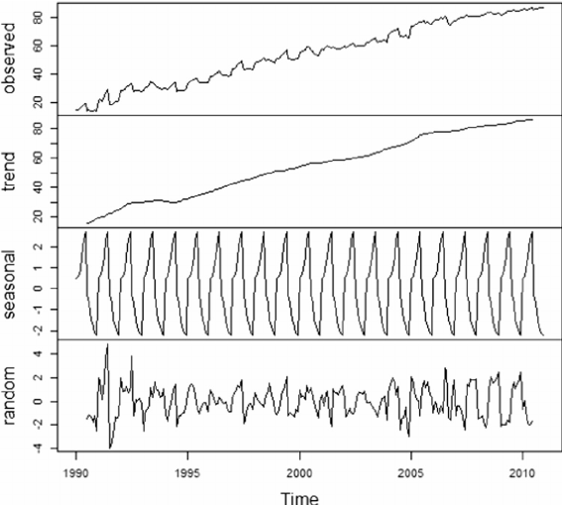

- Stationarity:When a time series has consistent statistical properties, like mean and variance, over time. For example, if the average temperature in a city stays roughly the same year after year, it’s stationary
We use various tests to check if data is sationary or not :

Dickey-Fuller (DF) Test: Tests for stationarity with a simple model, checks for unit root.
Augmented Dickey-Fuller (ADF) Test: Enhanced DF test that accounts for higher-order autocorrelation, more robust stationarity test.
KPSS Test: Tests for stationarity with the null hypothesis being stationarity, complements the ADF test by confirming the stationarity.

- Auto corelation function:A measure of how much current values in your data are related to past values. If high sales today are likely to be followed by high sales tomorrow, that’s autocorrelation.

- Partial auto corelation function:Similar to the ACF, but it shows the direct relationship between a value and its past values, ignoring the influence of the values in between. It helps identify the true lag effects.

- Dependence:The relationship between values at different points in time. If today's weather affects tomorrow's weather, they are dependent on each other.

- Exponential smoothing: Exponential smoothing is a forecasting technique used in time series analysis that applies decreasing weights to past observations, giving more importance to recent data points. This method helps to smooth out fluctuations and highlight trends by averaging the data in a way that reduces the impact of older observations.

4.Various challenges involved with tsa?

Non-stationarity:In time series analysis, non-stationarity occurs when the statistical properties of a series, such as mean, variance, and autocorrelation, change over time. This poses a challenge because many time series models, like ARIMA, assume the series is stationary. Non-stationary data can be caused by trends, seasonality, or other structural changes in the data over time.

Seasonality:Seasonality refers to regular, predictable patterns that occur at specific intervals, such as daily, monthly, or yearly. These patterns can complicate time series analysis because they introduce periodic fluctuations that can mask underlying trends and other important signals. For example, retail sales may peak during the holiday season and drop in the months following.

6. CASE STUDY USING DIFFERENT MODELS:

The case study involves an in-depth analysis of different time series analysis techniques applied to the monthly expenses data to predict the expenses of the employee in the next months. We draw insights into the data using these techniques and see which technique works best for various problem statements.

Sample Dataset :

Date | Expenses
2013-01-01 | 14236.90
2013-02-01 | 4519.89
2013-03-01 | 55691.01
2013-04-01 | 28295.35
2013-05-01 | 23648.29
2013-06-01 | 34595.13
2013-07-01 | 33946.39
2013-08-01 | 27909.47
2013-09-01 | 81777.35
2013-10-01 | 31453.39

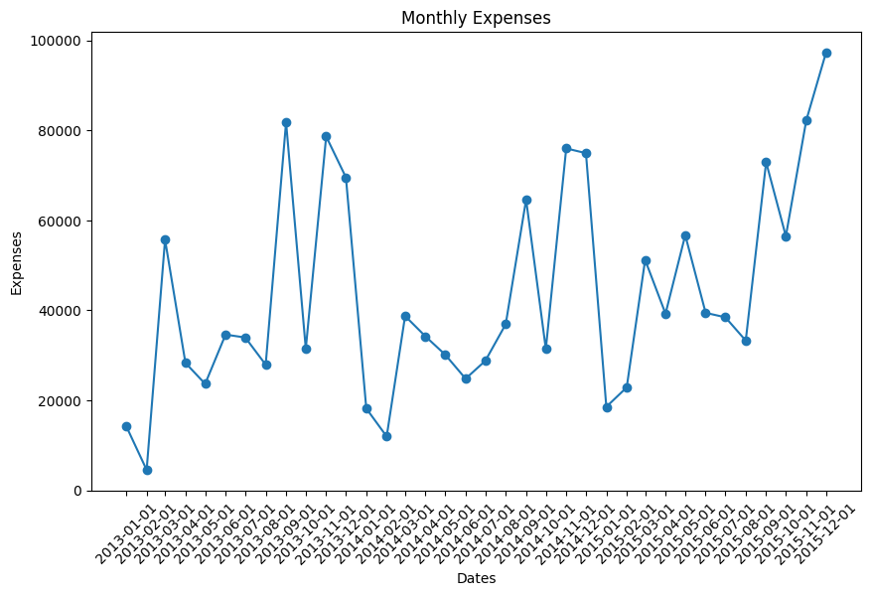

AR(Auto Regression) model:

It is the simplest model based on regression analysis and uses acf and pacf as basis.

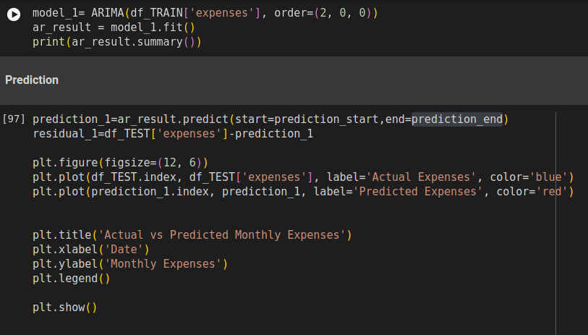
As u can sea from the code the arima function takes only the P() as input parameter therfore depicting it is a regressor model.

Prediction :

In the below graph red line shows predicted whereas blue line shows actual values.
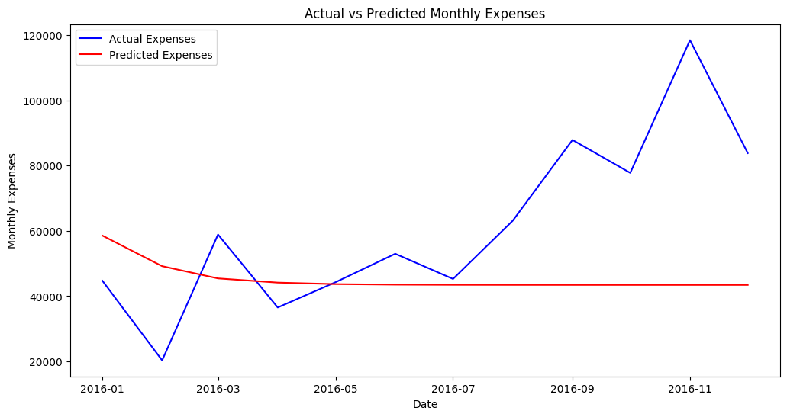

MA(Moving average) model:

The moving average modelis a statistical model used to predict future values in a time series based on past error terms (residuals).

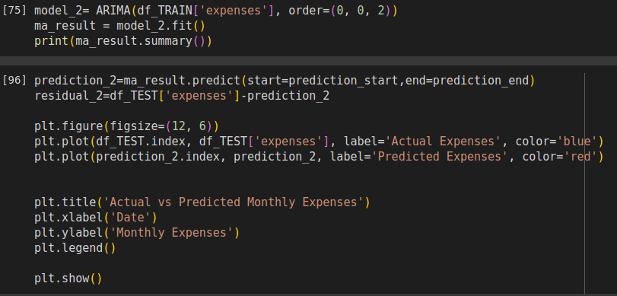
As u can sea from the code the ARIMA(p, d, q) function takes only the q() as input parameter therfore depicting it is a moving average model.

Prediction :
In the below graph red line shows predicted whereas blue line shows actual values.
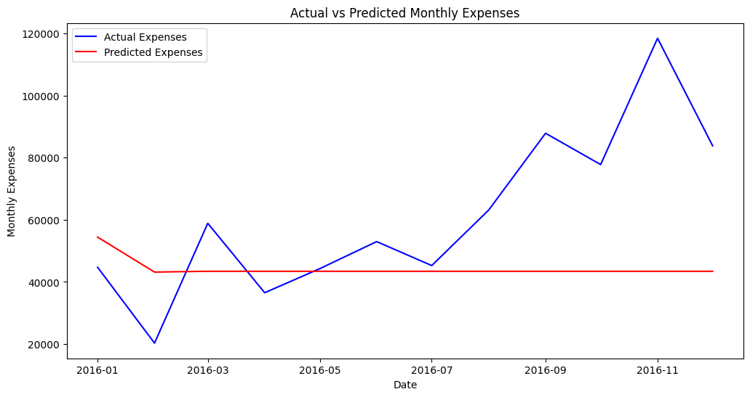

ARIMA(Auto regression integrated moving average)

A combination of autoregressive (AR), differencing (I for integrated), and moving average (MA) components to model time series data.

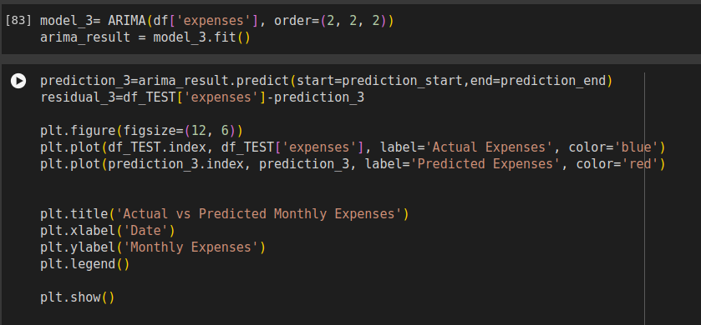
As u can see from the code the ARIMA(p, d, q) function takes all p() ,q() and d() as input parameter therfore depicting it is a ARIMA model.

Prediction :
In the below graph red line shows predicted whereas blue line shows actual values.

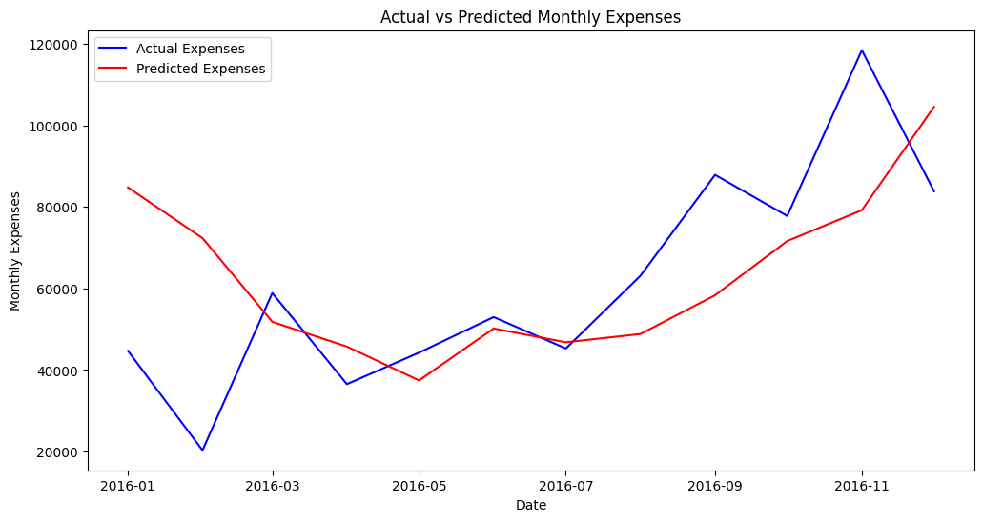
SARIMA model(Seasonal Auto regression integrated moving average)

The SARIMA model is an extension of ARIMA that incorporates seasonal components into the model.

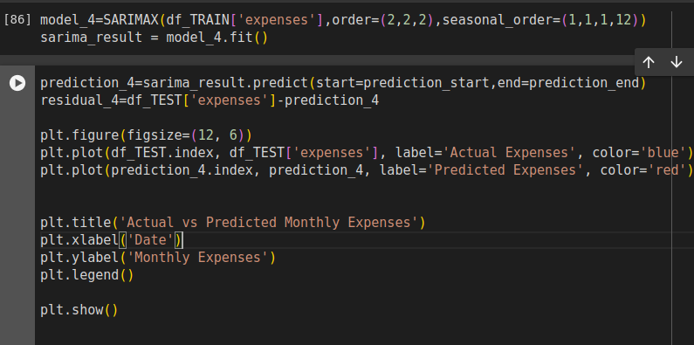

As u can see in the above code the sarimax dunction also incorporates a seasonal component in the previous arima model .
Prediction :
In the below graph red line shows predicted whereas blue line shows actual values.
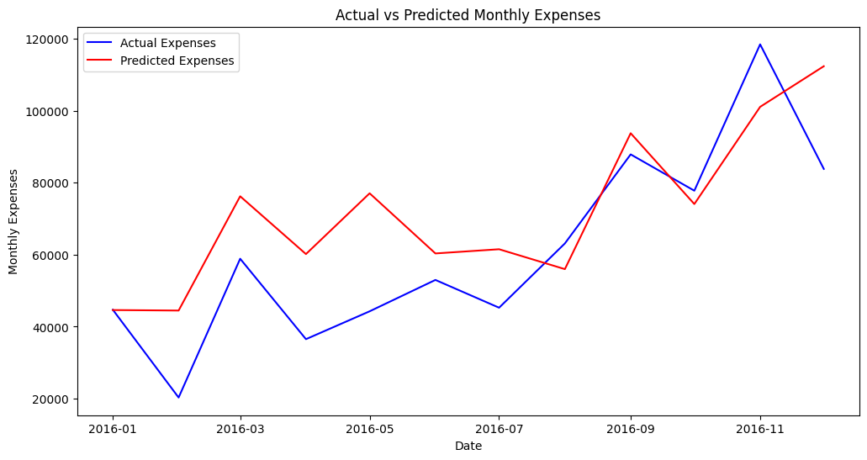

LSTM (Long short term memory)

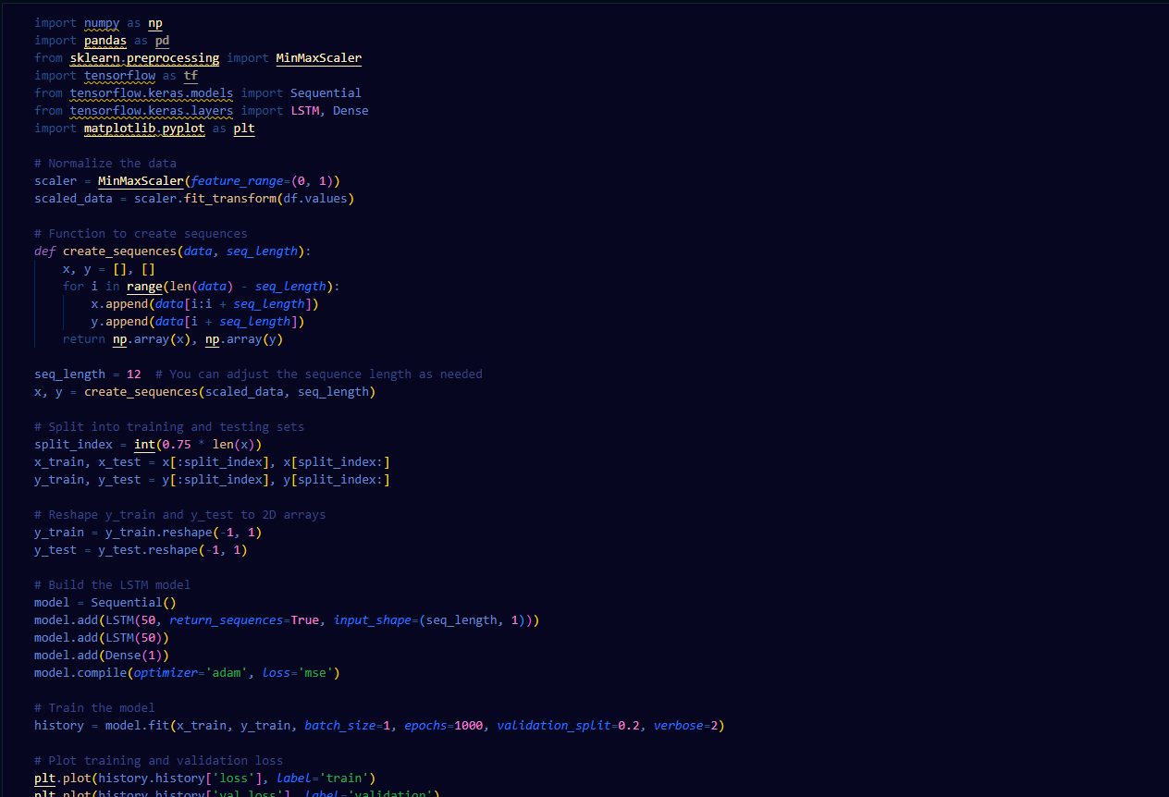
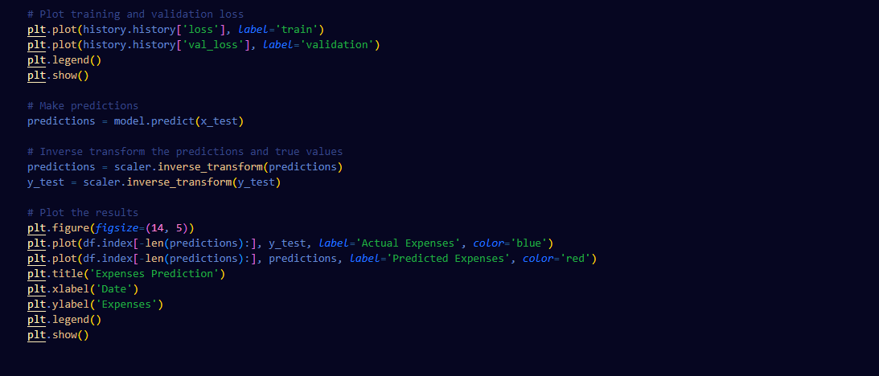

Prediction :
In the below graph red line shows predicted whereas blue line shows actual values.

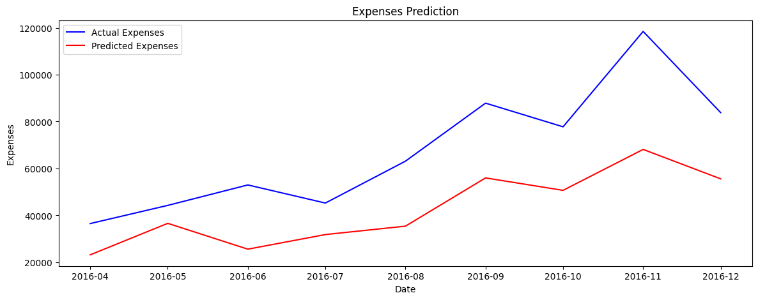

Combined graph for prediction

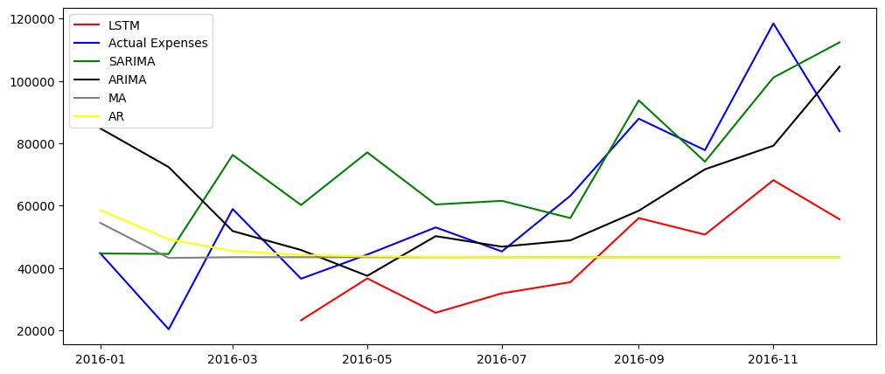

Conclusion:

We can see from the above graphs and predictions that :

- The predictions made by SARIMA model are best this is because along with the components of ARIMA model it also includes seasonality in the predictions.
- The predictions made by ARIMA model are better than AR and MA models because it uses combination of both AR and MA model along with differencing which brings stationarity to data.
- The AR and MA are basic models which uses simple statistical methods on which the other complex models such as ARIMA and SARIMA are based.
- The Lstm model performs best but the requirement for training a lstm model is that there must be a large amount of data present for the training for the lstm to predict accurately.

